Design and Implementation Document

Some Maze Service
Table of Contents
Some Maze Service 1

Design and Implementation Document Specification V0.1

1. System Architecture
- Application at large (highest level)
- Application architecture (component diagram w/ dependencies – mid level)
- Includes hosting, proxies, etc

2. Application Programming Interfaces
- API Design
- Endpoint contracts

3. End-user interface
- Website design
- Pages & mocks

4. Implementation Details
- API Class diagram (low level)
- Implementation decisions

5. Other Details (Notes, Concerns, Outstanding questions)

6. Detail Archive
Old design details & diagrams

7. Document Changelog

System Architecture

Application Programming Interfaces

End-User Interface

Implementation Details

Class Diagram
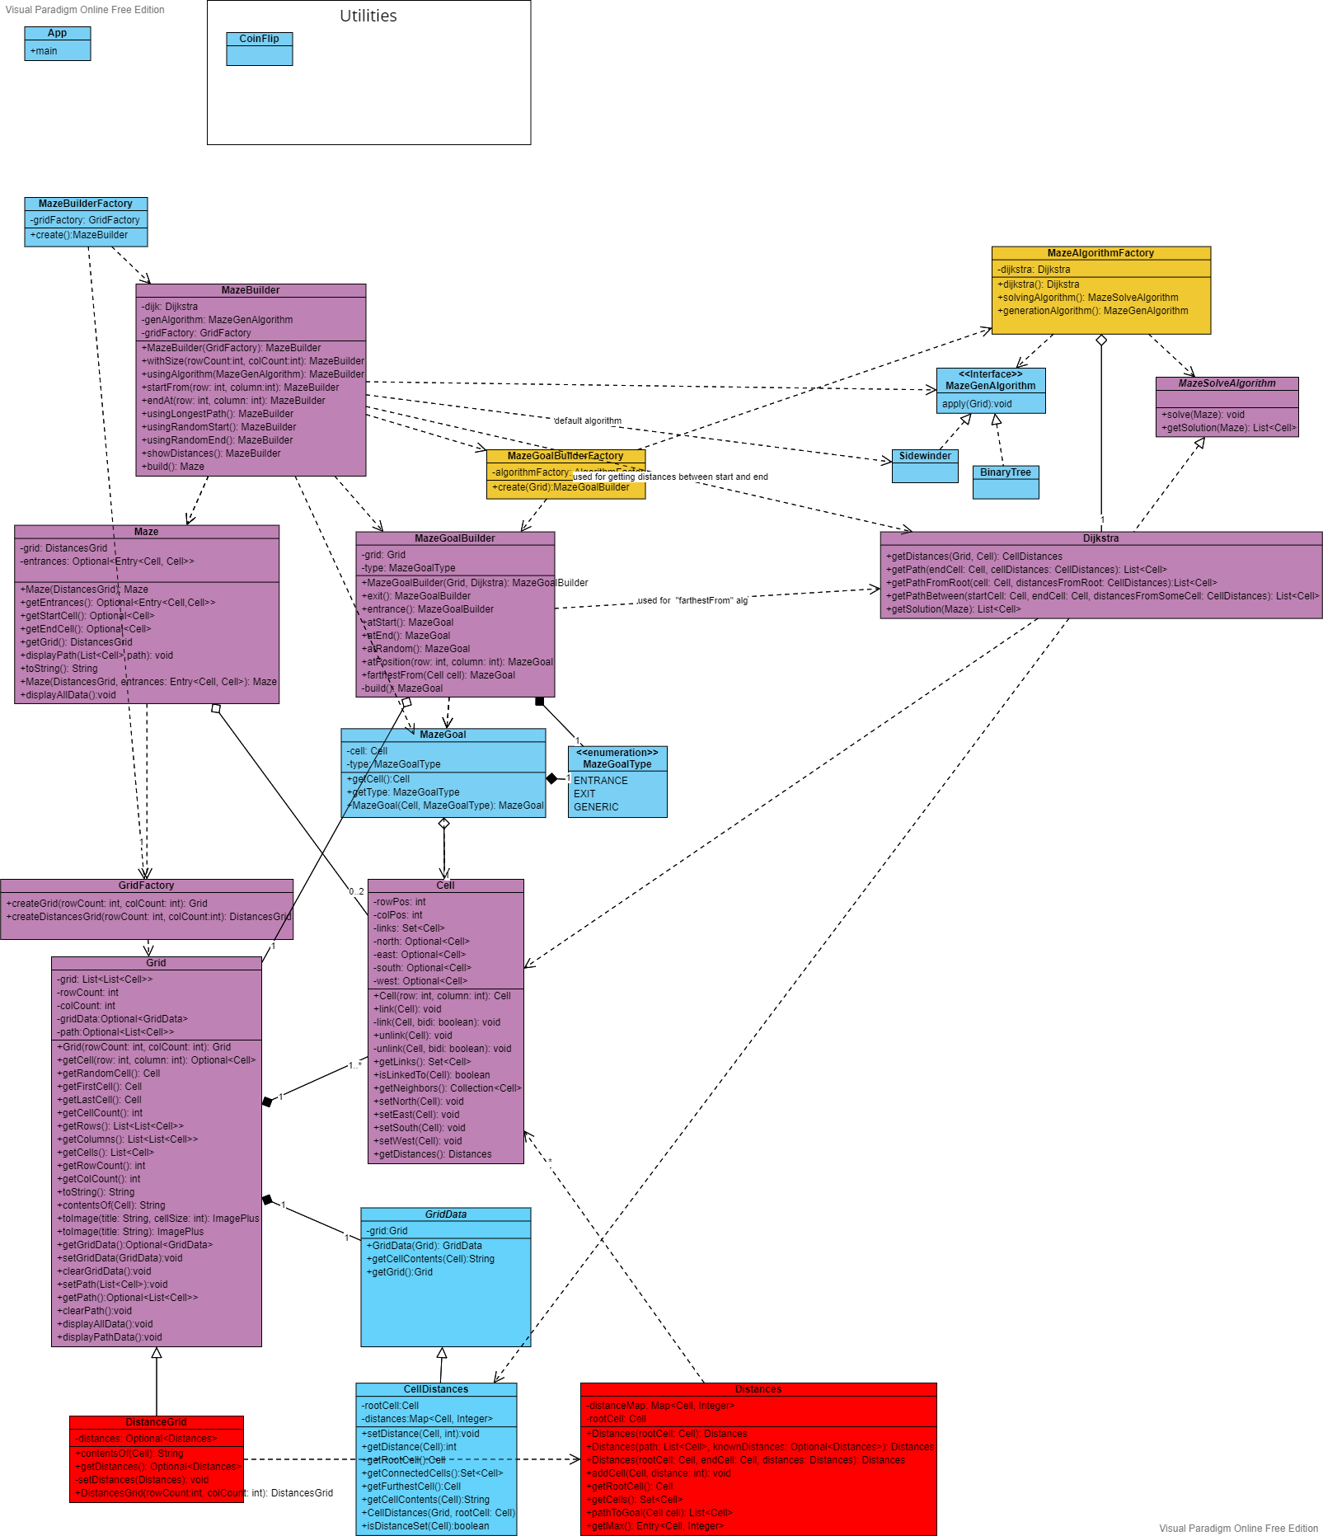

Proposal Details

Introduction of MazeGoalBuilderFactory
The purpose of this new factory class is to allow for IoC of the MazeGoalBuilder class within clients. The builder will have a new instance for every MazeGoal to be created by the clients. To remove the internal construction of these builders from clients, a factory class is needed. The factory will then be brought in via the IoC container in both application and test environments. This IoC pattern has already been done for the MazeBuilder class with MazeBuilderFactory.

Introduction of MazeAlgorithmFactory
The purpose of this new factory class is to allow for IoC of any of the maze algorithms and to provide a layer of abstraction for the algorithms. Instead of constructing the algorithm instances directly within within the client classes, they will now be brought in via the factory which will come in from the IoC container. In the future, this class will provide simple methods for getting the correct (or most appropriate) algorithms for the client. Anyways, such a class would become a necessity once an API layer is created and endpoints accepts an algorithm type as input.

Diagram Breakdown

Maze
todo

Grid
todo

MazeGoal
todo

Algorithms
todo

Solving Algorithms
todo

Generating Algorithms
Todo

Outstanding Questions
1. Factories, builders and constructed classes.
A. Should these be nested classes?
B. Should construction of Builders only ever be done via factories?

2. Should the core classes be made into components for Spring IoC container?
A. Is there a way to do this without changing the code to become Spring-specific? Separating framework from independent core code.
→ Yes. Requires more experimentation before I can get it work.

Testing:
Application.java
final var contextFactory = ApplicationContextFactory.of(() -> new ClassPathXmlApplicationContext("application-context.xml"));

new SpringApplicationBuilder(App.class)
//.contextFactory(contextFactory)
.headless(false)
.run(args);

resources/application-context.xml
<?xml version="1.0" encoding="UTF-8"?>
<beans xmlns="http://www.springframework.org/schema/beans"
xmlns:xsi="http://www.w3.org/2001/XMLSchema-instance"
xsi:schemaLocation="http://www.springframework.org/schema/beans
https://www.springframework.org/schema/beans/spring-beans.xsd">
<bean
id="dijk"
class="com.amw.sms.algorithms.Dijkstra"
/>
</beans>

https://stackoverflow.com/questions/30224485/spring-xml-configuration-location
https://stackoverflow.com/questions/52659474/do-we-have-xsds-particularly-for-spring-5-x
https://stackoverflow.com/questions/69979290/migrating-to-springboot-2-issue-when-using-xml-bean-definition-file
https://stackoverflow.com/questions/3907833/spring-applicationcontext-xml-cannot-be-opened-because-it-does-not-exist

Other Details

Archive

Class diagrams

4/20/22 – Replace Distances proposal V2.0

